Churches So Beautiful They’ll Take Your Breath Away
- Art
- Lists
by ChurchPOP Editor -
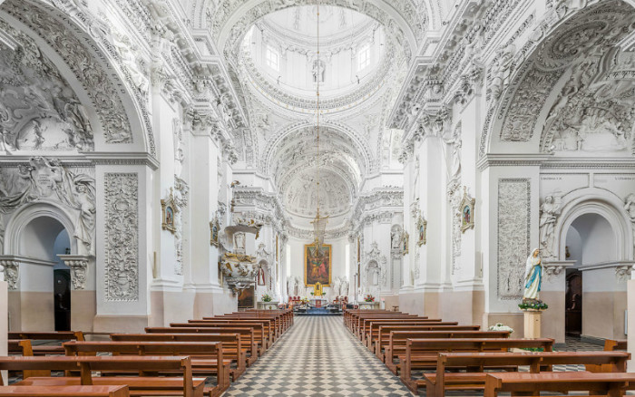
Diliff, Wikipedia
Yes, all of these places actually exist!
[See also: QUIZ: Modernist Church or Communist Building?]
[See also: QUIZ: Can You Match These Liturgical Latin Phrases With Their Meanings?]

St. Peter and Paul’s Church – Vilnius, Lithuania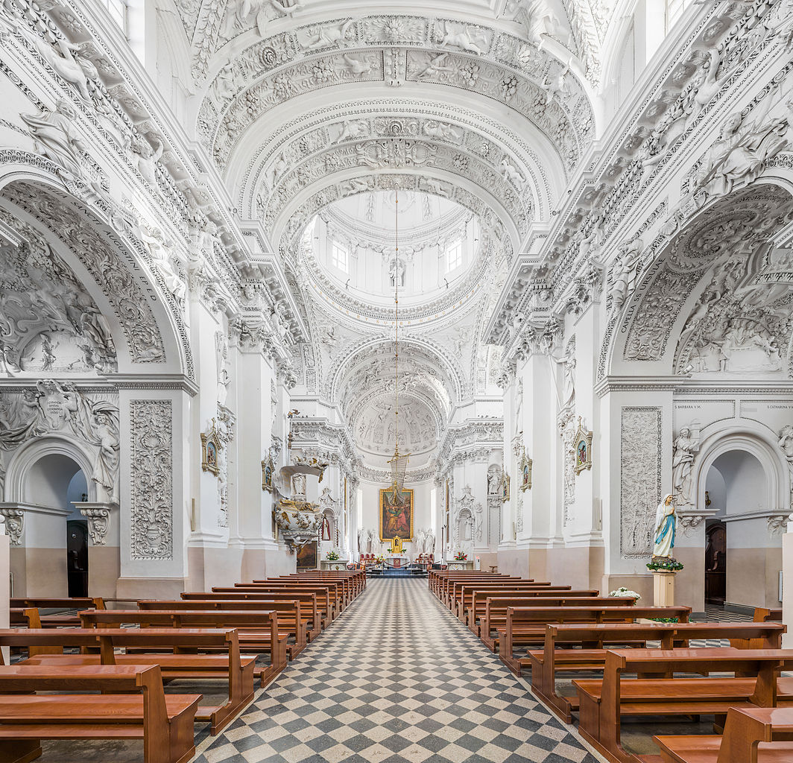

Diliff, Wikipedia

Basilica of the Virgin Mary – Krakow, Poland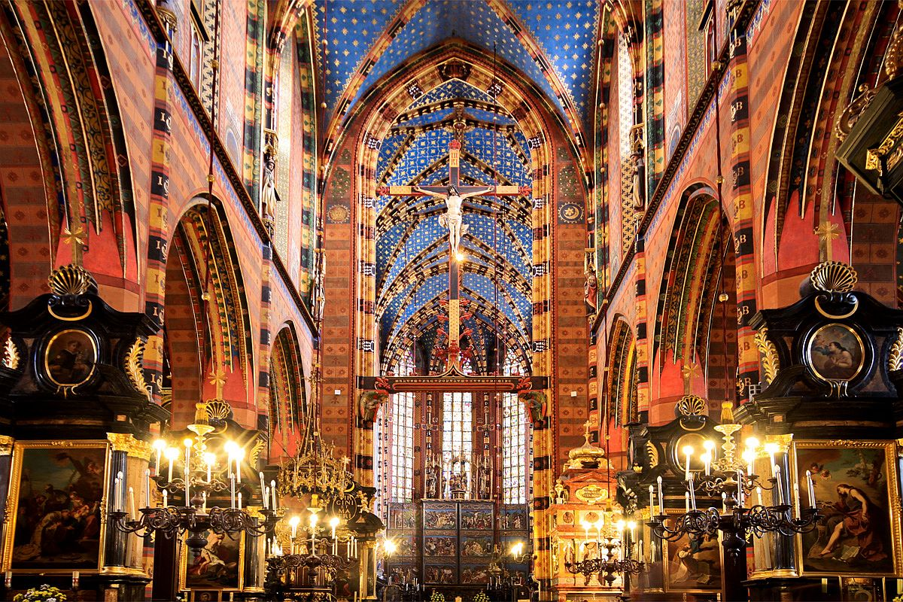

Ministry of Foreign Affairs of the Republic of Poland, Flickr

Church of St. Francis of Assisi – Prague, Czech Republic
Miroslav Petrasko, Flickr

St. Stephen’s Basilica – Budapest, Hungary
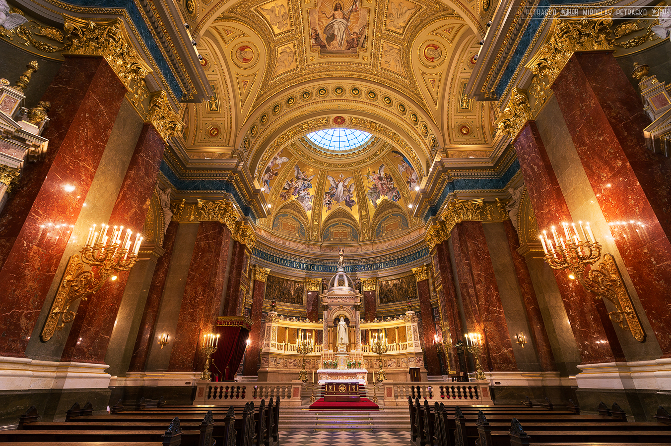
Miroslav Petrasko, Flickr

Church of St. Anne – Warsaw, Poland
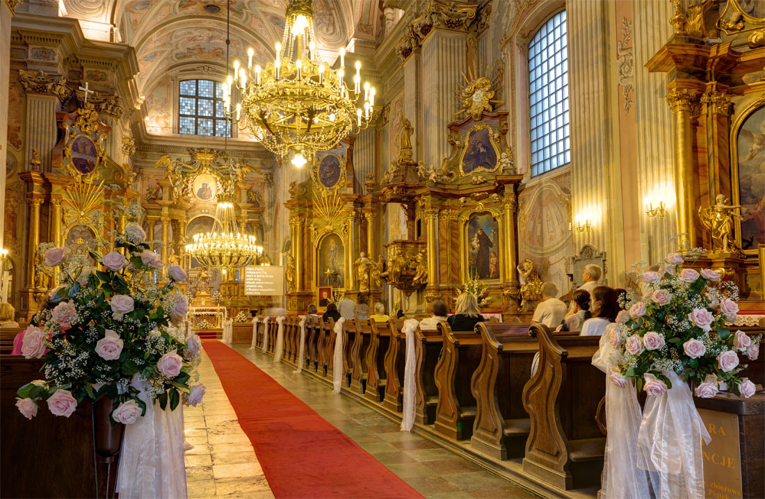
Michael Caven, Flickr

Holy Ghost Church – Denver, Colorado
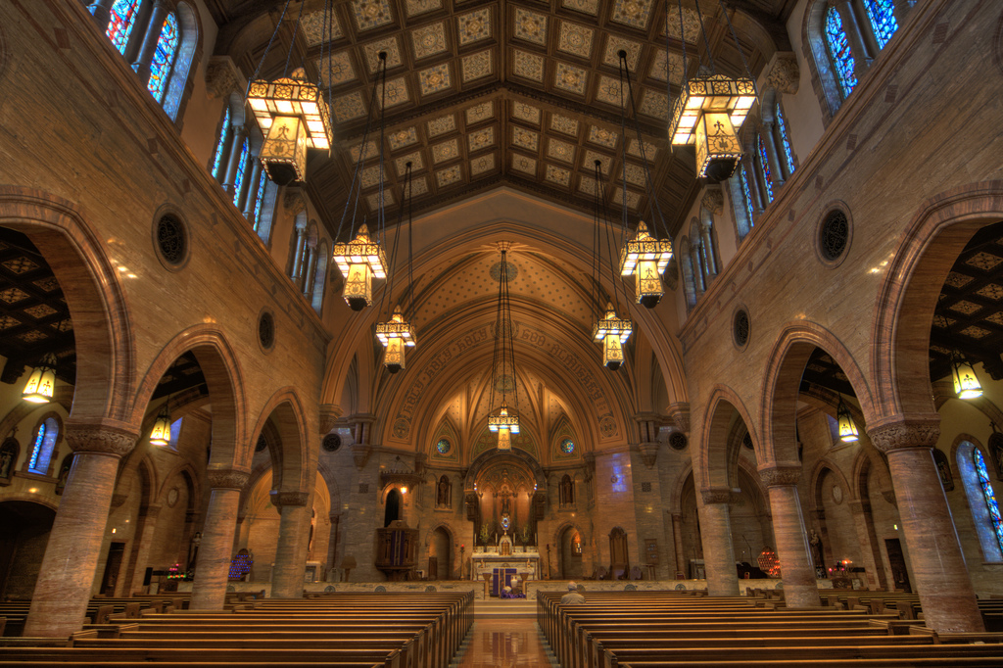
Dixie Lawrence, Flickr

St. Charles’s Church – Vienna, Austria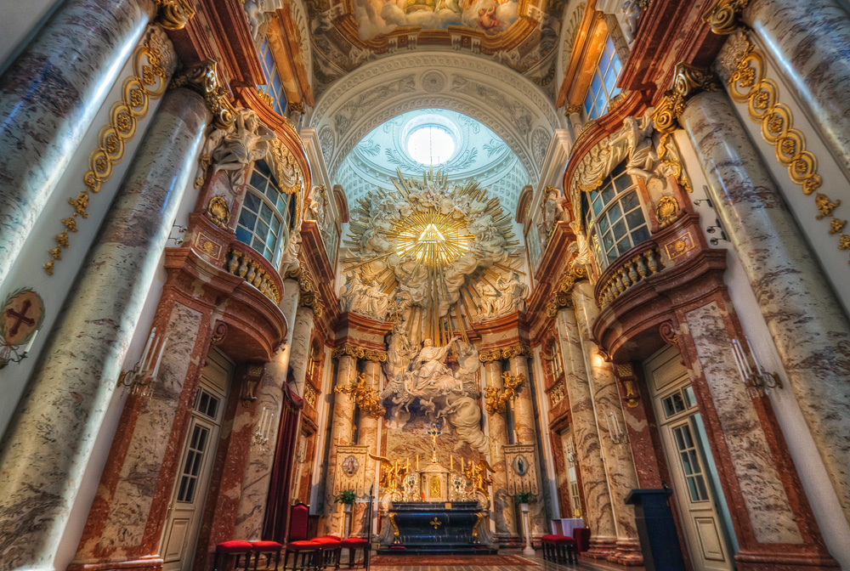Miroslav Petrasko, Flickr

Saint Isaac’s Cathedral – Saint Petersburg, Russia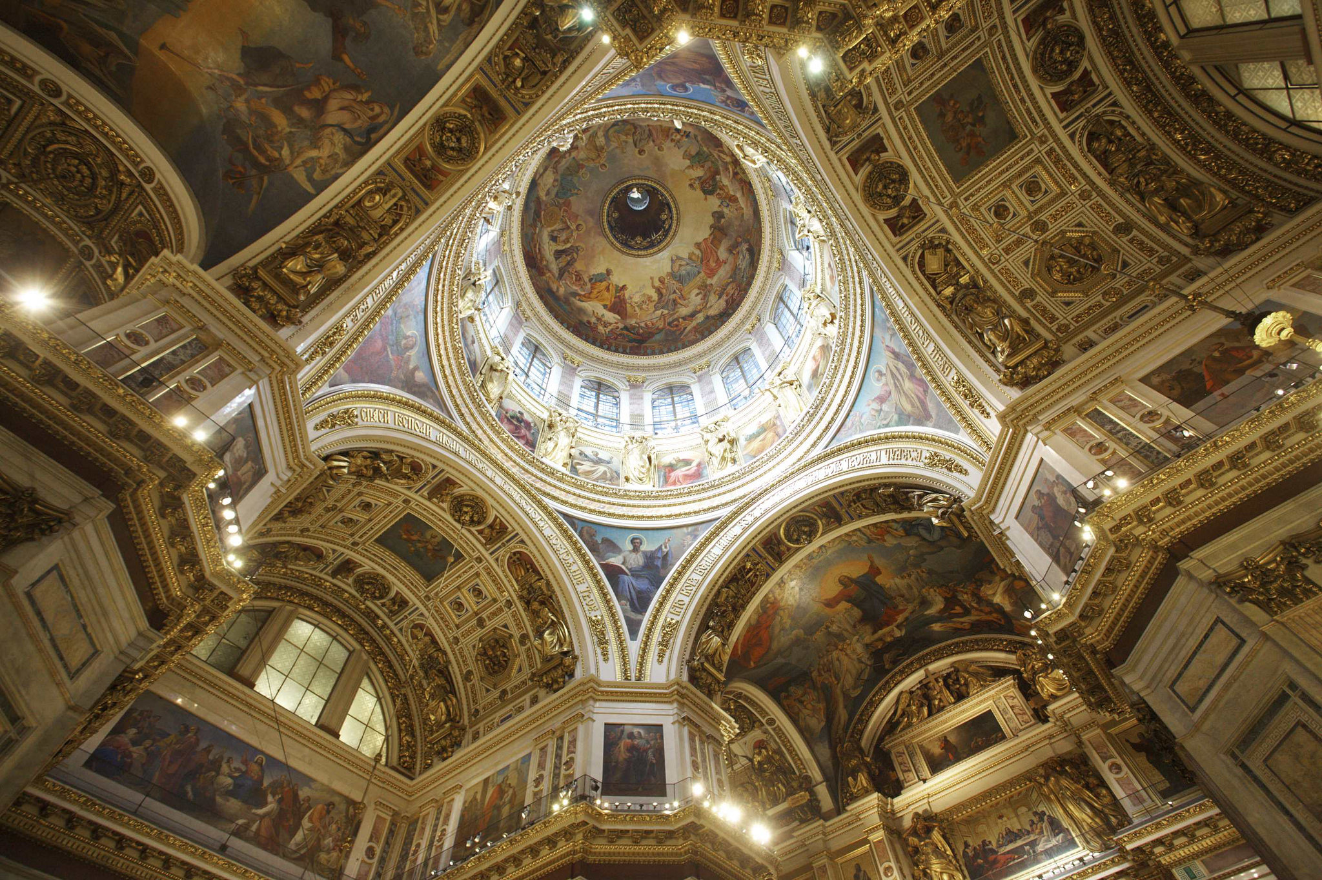

Benjamin Jakabek, Flickr

St. Andrews Church – Kirby Grindaylthe, England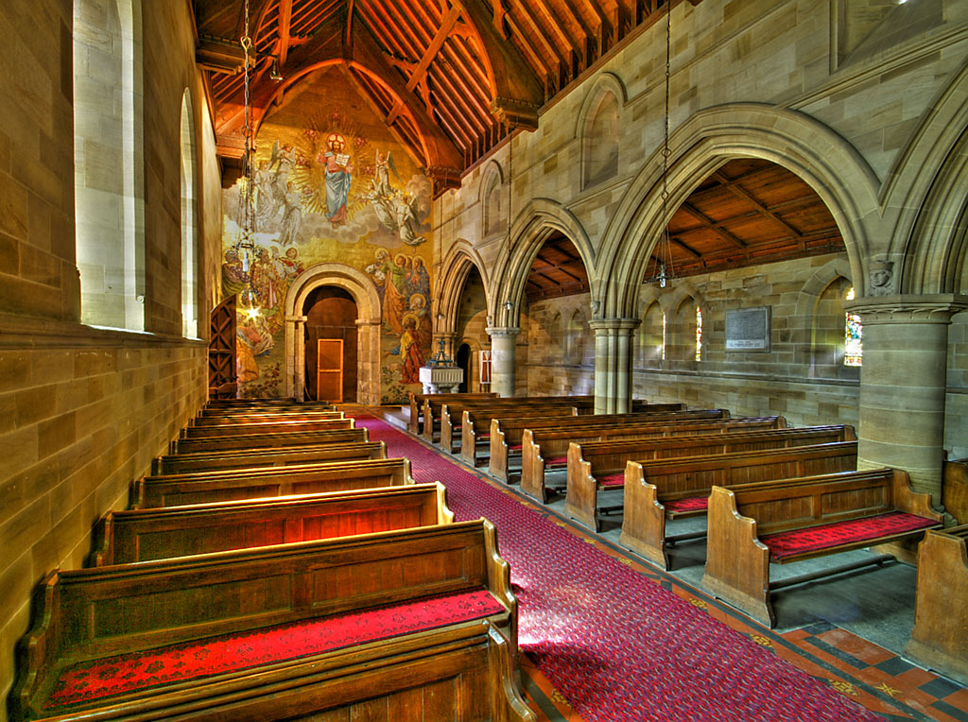

Nick Garrod, Flickr

St. Sava Serbian Orthodox Cathedral – New York City, New York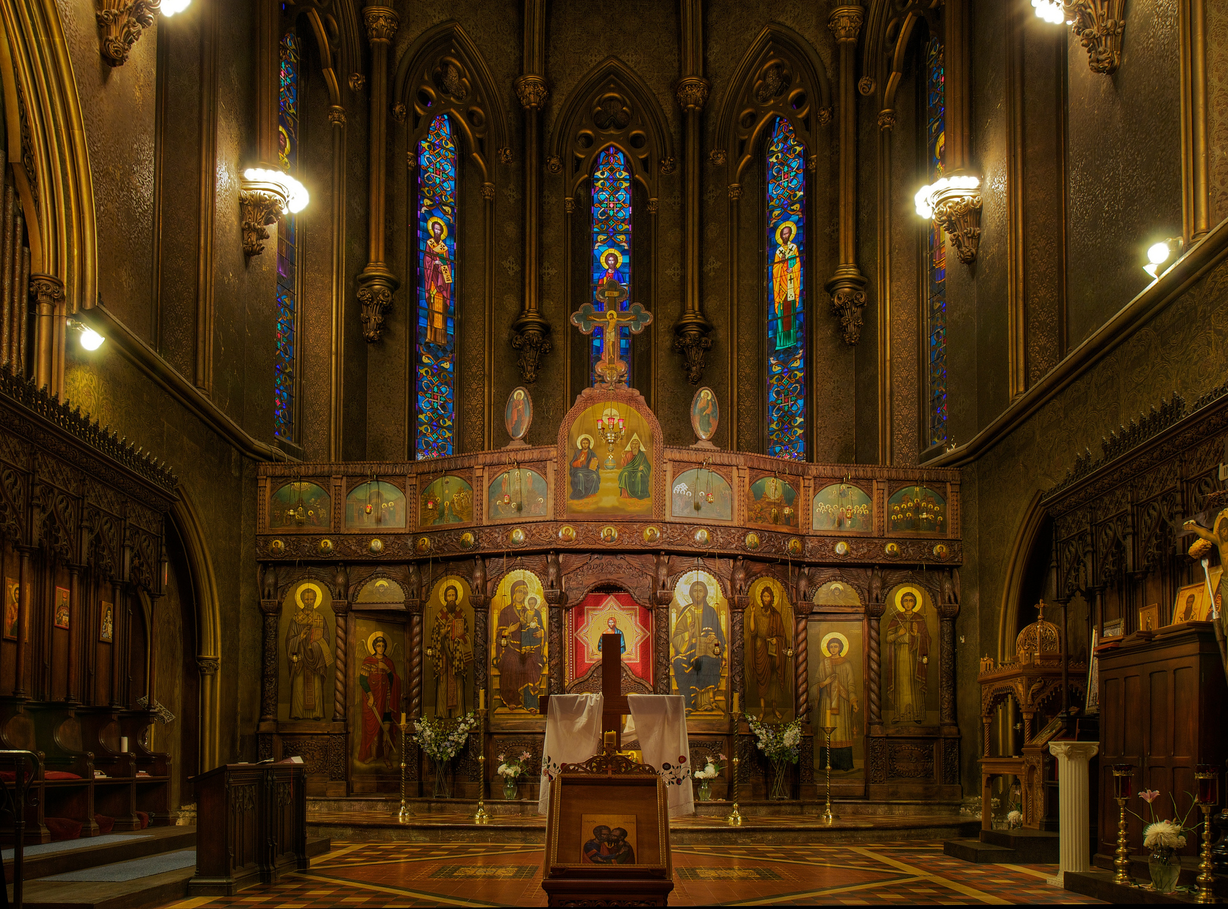

Kent G Becker, Flickr

St. Mark’s Basilica, Venice, Italy
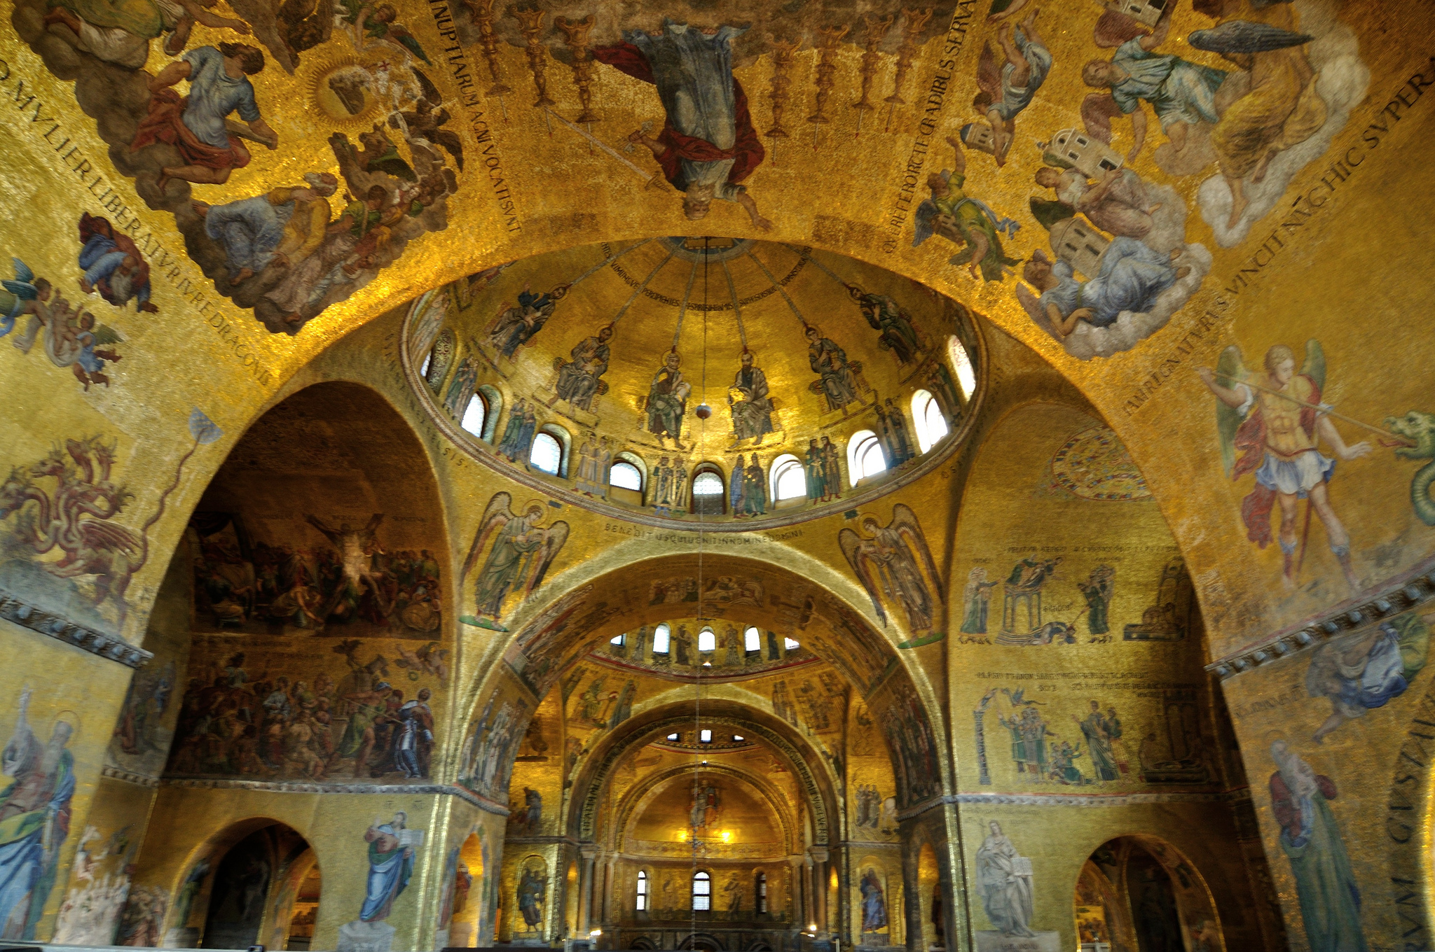-Reji, Flickr

St. Francis Xavier Church – New York City, New York
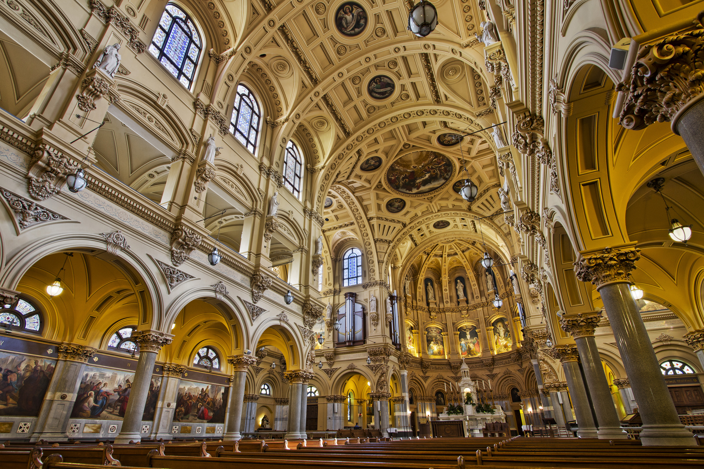Kah-Wai Lin, Flickr

San Francisco el Grande Basilica – Madrid, Spain
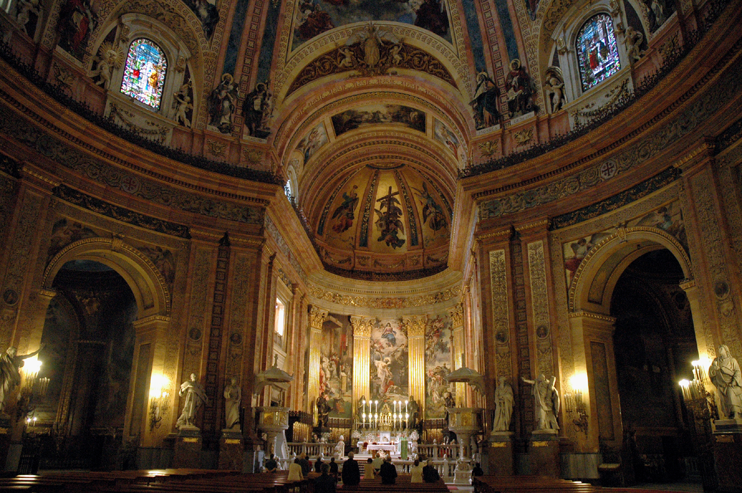San Francisco el Grande Basilica, Flickr

St. Paul Basilica – Rome, Italy
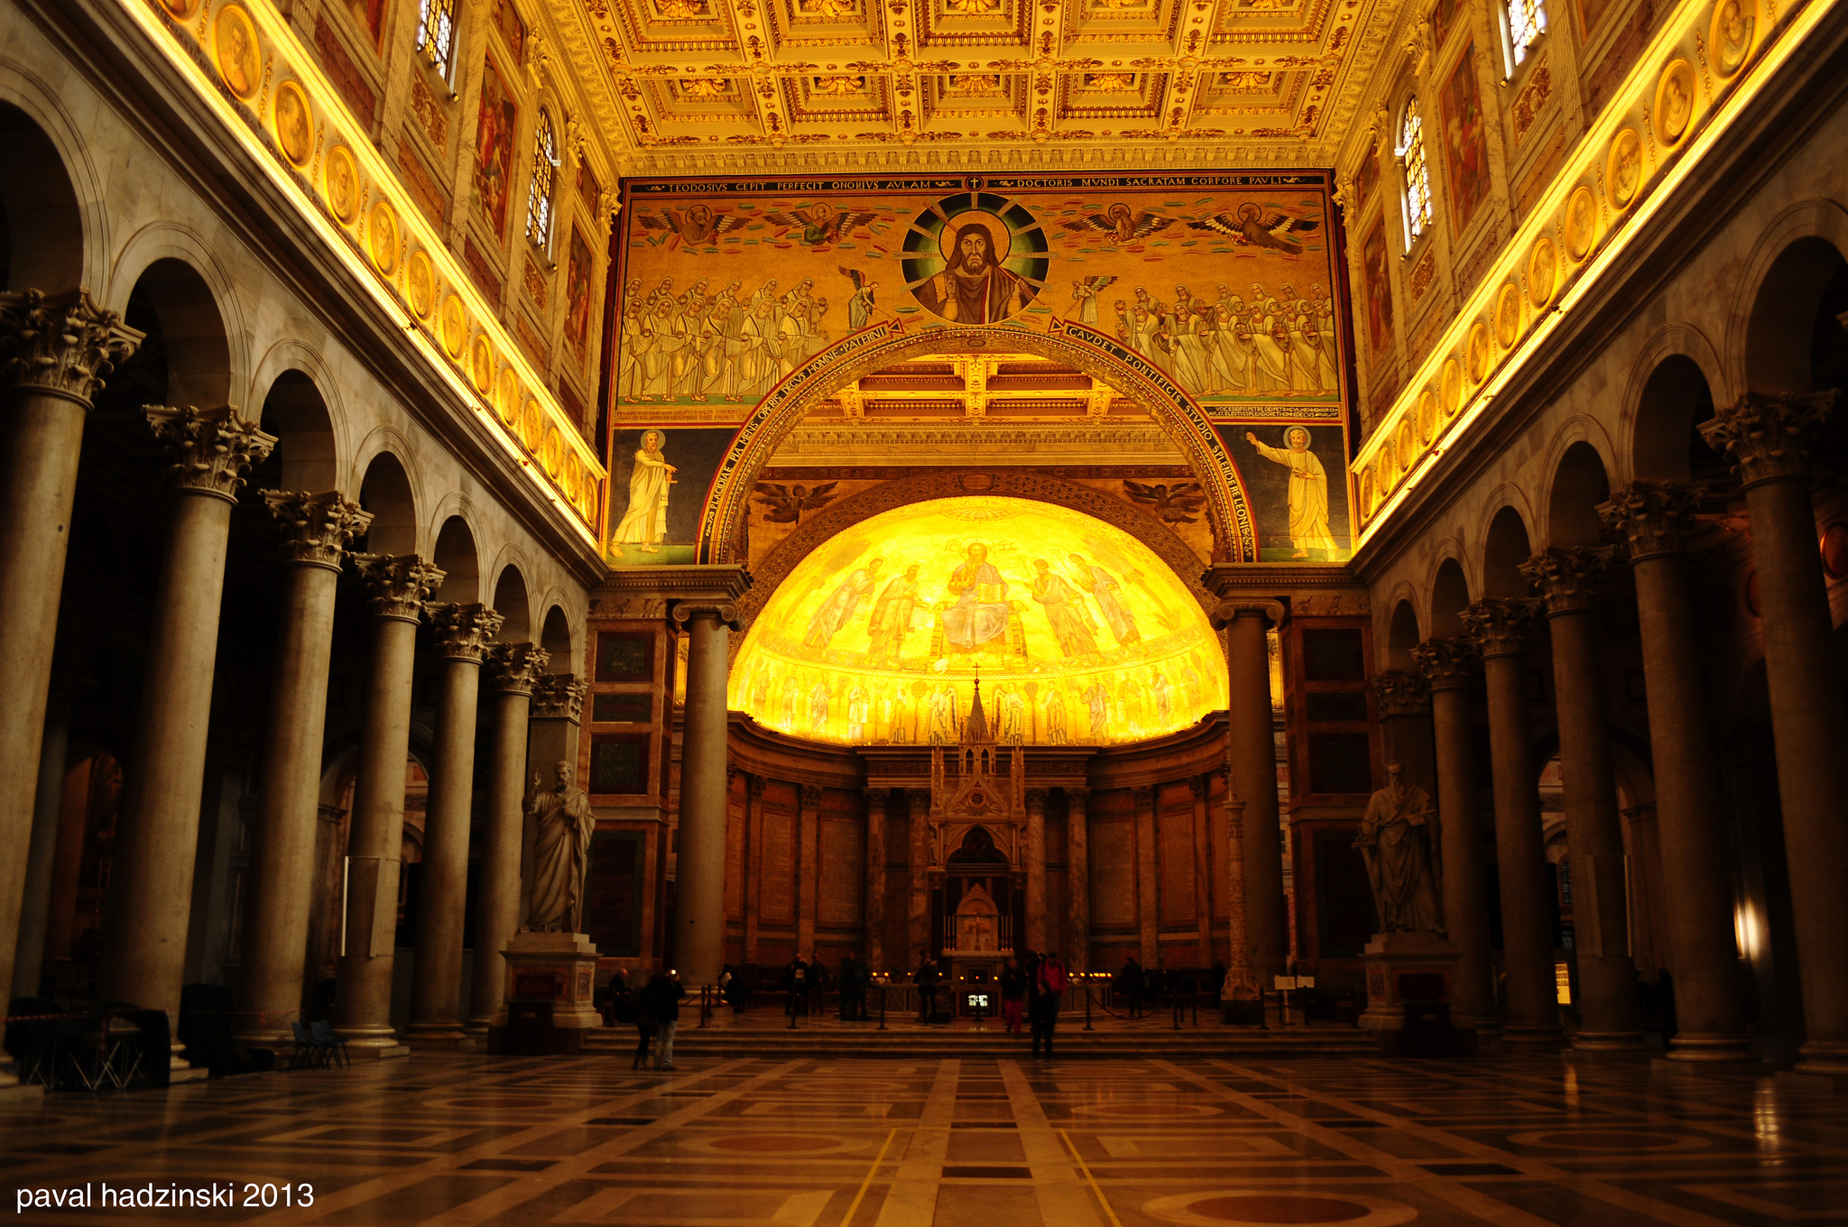
Paval Hadzinski, Flickr

St. Aloysius Church – Glasgow, Scotland
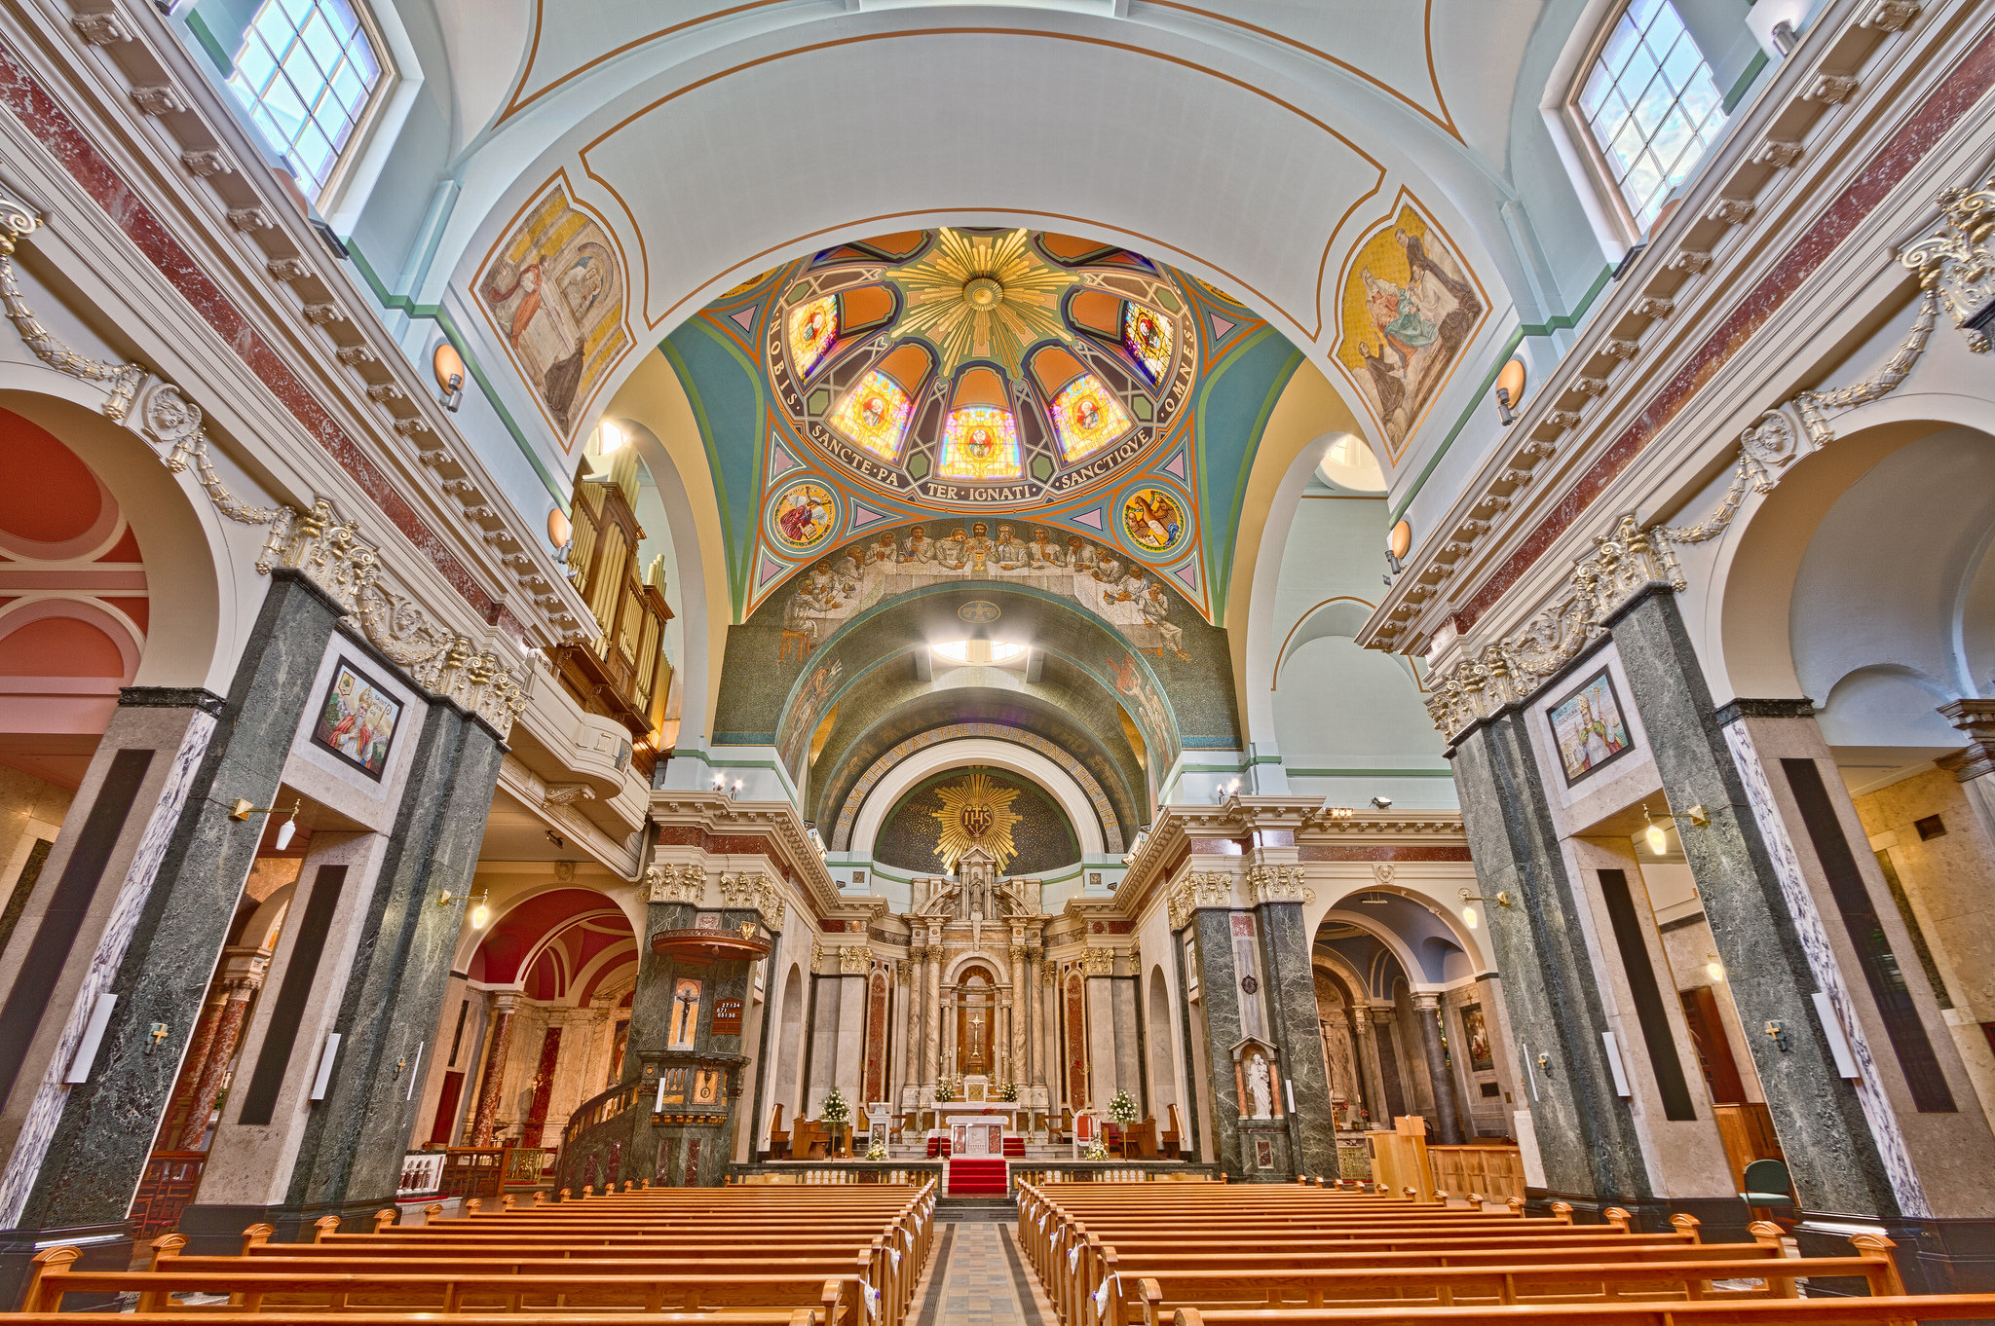
Michael D Beckwith, Flickr

And of course…St. Peter’s Basilica – Rome, Italy

